# Adventures in Reindeer Land

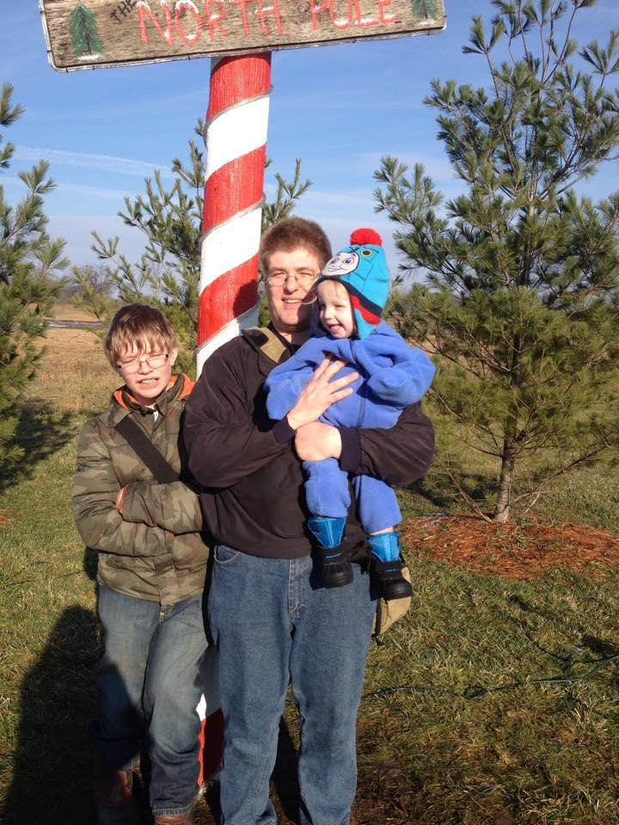

Today the kids and I drove north a little bit to the [Rooftop Landing Reindeer Farm](https://www.facebook.com/pages/Rooftop-Landing-Reindeer-Farm/114609902028185) to check out their Frozen-themed event. There were going to be some animals to see, and a chance for Elijah to visit with Santa Claus.

This was our first visit to the farm located between Rosebush and Clare. When we arrived, it was so busy that cars were already parking on the lawn. You could see that the tires were cutting into the soft ground, and as we walked around the car, our feet would sink in and water would squish out.

Almost all of the activities were being held inside “Santa’s Workshop.” We paid the $2 admission for adults and kids (Elijah got in free) and then began checking out their collection of animals. Elijah got a kick out of seeing the llamas, and enjoyed watching the reindeer too, although he tended to walk back to the llamas. Although we explained what each animal was, he would only refer to them as “cows.”

The visit with Santa was not as successful. As soon as I set Elijah on his lap, he began crying so hard that he knocked off Santa’s hat. I called Kayla over to sit with him, but this hardly made a difference. But, I snapped the photo:

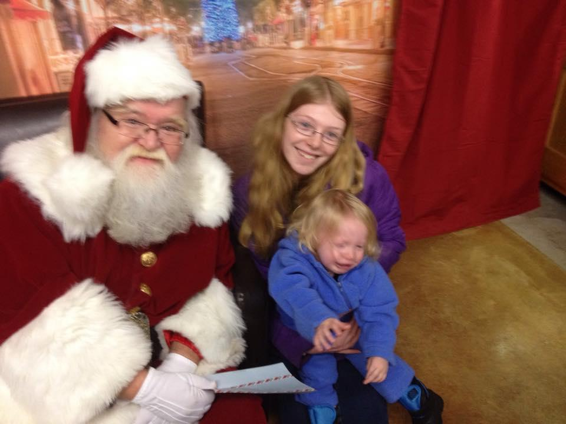

Shortly after the visit with Santa, we passed by the llamas one more time before wandering outside to check out the other reindeer pen. Satisfied, we headed back to the car. I was already a little worried about getting stuck on the way out, and it wasn’t reassuring when we saw a minivan having to be pulled out of the muck. Once all of the kids were settled, I manuevered the car around and we were soon on our way back home.

We stopped by the library in Mount Pleasant on the way home, where Elijah “helped” me pick out videos to rent. He then made a game of removing all of the magnetic gears off of the whiteboard in the children’s section and dropping into the chair I was sitting on. After a while, we packed up and hit the road once again, this time we were on our way straight home.

[View Online](https://docs.google.com/document/d/1lpFOx6q5xhjz6RvYPym18wF10_m46esvDxlbthgSZBI/pub) / [Discuss](https://docs.google.com/document/d/1lpFOx6q5xhjz6RvYPym18wF10_m46esvDxlbthgSZBI/edit?usp=sharing) / [Photo Gallery](http://cyberland.github.io/blist/gallery_2562.html) / [Return to Blist](http://cyberland.github.io/blist/index.html)